PRE MODEL EXAM:

MONISH RAJ.C

1. 192221056

#include<iostream>

using namespace std;

class person{

private:

string name,country;

int age;

public:

void get(){

cout<<"enter your name:";

cin>>name;

cout<<"enter your age:";

cin>>age;

cout<<"enter your country:";

cin>>country;

}

void set(){

cout<<"name="<<name<<endl;

cout<<"age="<<age<<endl;

cout<<"country="<<country<<endl;

}

};

int main(){

person obj;

obj.get();

obj.set();

}

OUTPUT:

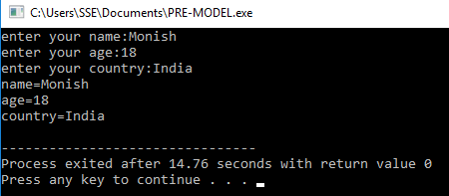

2.

#include<iostream>

using namespace std;

class rectangle{

public:

int L,B;

rectangle(){

L=0;

B=0;

}

void fc(){

cout<<"area of rectangle:"<<L\*B<<endl;

}

rectangle(int a,int b){

L=a;

B=b;

}

void fc1(){

cout<<"area of rectangle:"<<L\*B<<endl;

}

rectangle(int a){

L=a;

B=a;

}

void fc2(){

cout<<"area of rectangle:"<<L\*B<<endl;

}

};

int main(){

rectangle obj1,obj2(2,4),obj3(4);

obj1.fc();

obj2.fc1();

obj3.fc2();

}

OUTPUT:

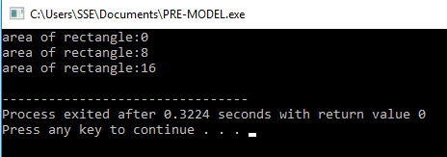

3.

#include<iostream>

using namespace std;

int main(){

int r;

cout<<"no of rows:";

cin>>r;

for(int i=1;i<=r;i++){

for(int j=1;j<=i;j++){

cout<<"1 ";

}

cout<<endl;

}

return 0;

}

OUTPUT:

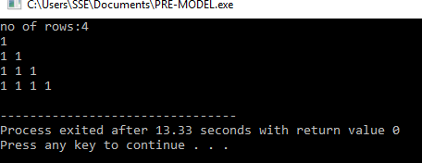

4.

#include<iostream>

using namespace std;

class person{

public:

string name,city;

int age;

person(){

cout<<"enter your name:";

cin>>name;

cout<<"enter your age:";

cin>>age;

cout<<"enter your city:";

cin>>city;

}

void display(){

cout<<"your name="<<name<<endl;

cout<<"your age="<<age<<endl;

cout<<"your city="<<city<<endl;

}

};

class student:public person{

public:

int m[5];

float a;

student(){

a=0;

for(int i=0;i<5;i++){

cout<<"mark"<<i+1<<"=";

cin>>m[i];

}

}

void show(){

for(int i=0;i<5;i++){

a=a+m[i];

}

cout<<"average="<<a/5;

}

};

int main(){

student obj2;

obj2.display();

obj2.show();

}

OUTPUT:

